Form 2A
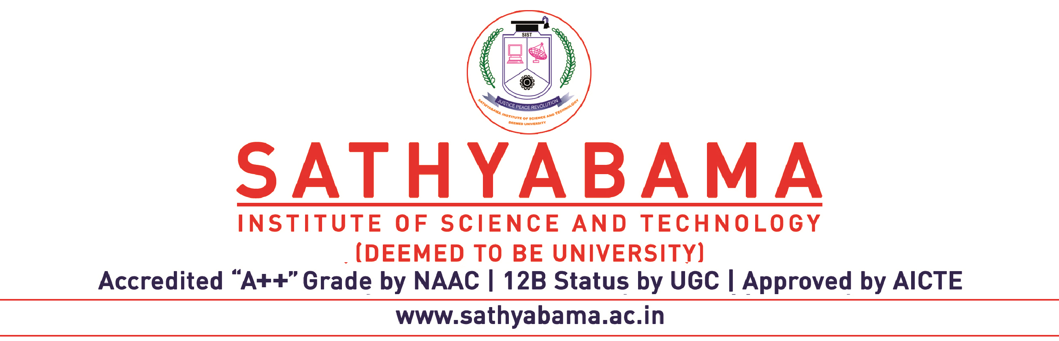

Date:

APPLICATION FOR ARREAR COURSE WORK PERMISSION FOR Ph.D PROGRAMME

Name of PhD Scholar : _______________________________ Register Number: ________________
Mail Id: _________________________________________________ Mobile No : ______________________
Name of Supervisor & Designation : _______________________________________________________________

Contact No & Mail ID : ______________________________________________________________________

Details of the Examination Fee paid : No of course work appearing X Rs 1000/-
Fil e No.
Total Amount =

(Coursework Fee to be paid through Sathyabama online fee portal )
Enclose the Ph.D Hall Ticket along with this form mentioning the details of the courses to be written in the current semester examination

Sl. No. | Subject Code | Name of the COURSE | Type of the Subject (Arrear) | Name of the PG Programme where the course belongs | Signature of Dean where the research scholar has registered for Ph.D

Signature of the Research scholar Signature of the Supervisor

Director (Research)

NOTE:
- Candidate should take PG level courses only.
- Candidate should take only the offered elective subjects.
- Supervisor should get approval for direct study syllabus from the Director (Academic Research).
- 80% Attendance is compulsory for writing the course work examination including direct study.
- Subject name mentioned in this form should be the same as mentioned in the First DC Meeting minutes.
- Candidate should get signature only for the course registered in the current semester.
- Candidate should attach a copy of First DC meeting minutes and Syllabus.
- For Directed Study Course work, Candidate should attach a copy of the approved syllabus.
NOTE:
- It is the responsibility of candidate to collect the Student ID card with in a month’s time after submission of this form (ID Card should be brought along with Hall Ticket on the day of Course Work Examination)

[Please see next page for Hall Ticket]

EXAM HALL TICKET
PhD REGULAR COURSE WORK / DIRECTED STUDY / SPECIAL ELECTIVE/ ARREAR
Month & Year of Examination: May – June 20.…. / Nov – Dec 20…..

Name of the Student :

Register Number:

Subject Codes:

……………… …………………. ……………….
Signature of Controller of Examinations Director (Research)
the Candidate

Affix Passport Size Colour
Photo

Instructions to Research Scholars

- All scholars should bring their Hall ticket and valid identity card for every examination for verifying their identity in the examination hall, failing which they will not be permitted to write the examination.

- The scholars are advised to view their seating arrangements for both Regular / Arrear / Directed study Examinations at the Exam Office Notice Board on the day of the Exam.

- The scholars are strictly not permitted to possess Cell Phones / Programmable Calculators inside the examination hall. Any violation of this will be viewed very seriously and it will be confiscated.

- Data books/IS codes/Graph Sheets / Tables will be issued by the University only.

- The scholars are advised to enter the examination hall 10 minutes before the commencement of examination. They should come in the official dress code.

- Scholars will be allowed to leave the Exam halls only at the end of three hours.
- Exam Timings : Forenoon Session – 9.30 A.M to 12.30 P.M.
Afternoon Session – 1.00 P.M to 4.00 P.M.

- MALPRACTICE DURING EXAMINATIONS :
If a scholars t has been caught indulging in any malpractice any of the University Theory or Practical Examinations, severe action will be taken, as per the University rules and regulations.

